**IBM HACK CHALLENGE REPORT**

**Topic: AI BASED SHORTLISTING**

**Duration Of PROJECT : 4 Weeks**

**Submitted By:**

**TEAM CODEVISION**

**Paras Thareja**

**(BVCOE College)**

**ACKNOWLEDGEMENT**

I express my deep gratitude to **Mr. Hemant , Mr Prashanth , Mr Charan and Ms. Lalitha**

for their valuable guidance and suggestions throughout my project work.

Last but not the least I would like to thank my friends, family members and all those people who helped me for the completion and deeper understanding of the concept of machine learning. Working on this project was an enlightening experience for me.

**Sign**

Paras Thareja,

BVCOE, Delhi

**PROJECT SCHEDULE:**

**This Project Schedule Was Provided to us Through the SmartInternz Platform :**

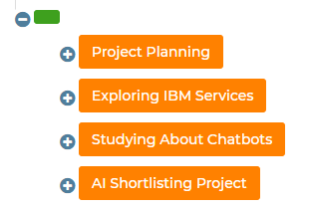

1. **Introduction:**

**Project Overview:**

A recruitment chatbot – or “conversational agent” – is a software application designed to mimic human conversational abilities during the recruiting process.

Similar to virtual personal assistants such as Alexa, Siri, and Google Now, a recruitment chatbot uses AI technology such as natural language processing to understand a person’s messages and know how to respond.

A chatbot can be used within various media:

* email
* SMS
* social media profiles like Facebook
* messaging apps like Slack
* specific software such as an ATS

A chatbot can mimic a human’s conversational abilities in the sense that it’s programmed to understand written and spoken language and respond correctly.

To what extent a chatbot can pass for another human being, however, still remains the same.

**The benefits of using a chatbot**

Interest in chatbots is accelerating due to the benefits they hold for both recruiters and candidates.

**Benefit #1: Candidates are comfortable interacting with a chatbot**

The #1 request from job seekers is “more communication.”

As Alexa, Siri, and Google Now become more common in our personal lives, communicating with a chatbot during the recruiting process is being embraced by candidates.

In a recent survey by Allegis, 58% of candidates were comfortable interacting with AI and recruitment chatbots in the early stages of the application process. An even larger percentage – 66% – were comfortable with AI and chatbots taking care of interview scheduling and preparation.

Today’s candidates are aware the recruiting process might not be human-to-human at every touchpoint, but value the chance to receive information in whatever way they can. Randstad found 82% of job seekers believe the ideal recruiter interaction is a mix between innovative technology and personal, human interaction.

As that attitude continues to evolve, so will the recruitment chatbot.

**Benefit #2: A chatbot can help recruiters with administrative tasks**

A recruitment chatbot can:

* collect information from candidates such as their resume and contact information
* ask screening questions about candidates’ experience, knowledge, and skills
* rank candidates on metrics such as qualifications, engagement, or recent activity
* answer FAQs about the job and the application process
* schedule an interview with a human recruiter

All of this information can be collected in real life and simultaneously from hundreds to thousands of candidates. This information can then be fed into your ATS or sent directly to a human recruiter to follow up.

Over time, the machine learning component of the chatbot will begin to understand which metrics it should be looking for based on the data it collects and rank candidates accordingly.

**Benefit #3: A chatbot can help recruiters save a lot of time**

Industry estimates predict a chatbot can automate up to 80% of top-of-funnel recruiting activities.

According to SHRM, the average cost of hire is $4,129 and the average time to hire is 42 days. By automating a large part of qualifying and scheduling while simultaneously keeping candidates engaged, a recruitment chatbot can dramatically lower both cost of hire and time to hire.

It’s important to keep in mind though that a recruitment chatbot is *not* designed to replace a human.

It’s estimated that 65% of resumes received for a role are ignored. By interacting with this ignored 65% of candidates, a chatbot is doing the tasks that already time-strapped human recruiters don’t have the time nor capacity to do in the first place.

If a recruitment chatbot can more quickly screen out unqualified candidates, recruiters can focus their efforts on what they enjoy doing instead: creating connections and building relationships with interested candidates are qualified.

**The challenges of using a chatbot in recruiting**

While the market seems ripe for mainstream adoption, challenges for using a recruitment chatbot exist.

**Challenge #1: A lack of standardization in how people text**

Because people have different ways of texting (e.g., slang, emojis, short form), it’s extremely difficult to program a chatbot to understand each and every variation.

A chatbot can make a best attempt based on its programming and the knowledge it’s gained from previous interactions or turn the conversation over to a human when it gets stumped.

**Challenge #2: A lack of “humanness” in a chatbot**

There’s still a debate on how “human” a chatbot should – and could – be.

Most of us can agree with a chatbot shouldn’t be too robotic and cold because this type of “bot-speak” creates a poor user experience. On the other hand, some argue that we don’t need to aspire to create chatbots that can pass as human.

The happy medium most people can agree on is a chatbot that displays some elements of a personality such as humour and using slang.

**Challenge #3: Unknown reaction of candidates to a chatbot**

The mainstream adoption of chatbots in other functions such as customer service suggests chatbots have a promising role to play in recruiting.

Although industry surveys suggest candidates feel positive about interacting with a chatbot, no one can really predict what a candidate’s reaction will be when they actually converse with one.

Candidates’ reactions will likely largely depend on how well the chatbot can answer their questions and provide additional information about their job application.

WORKING BOT:

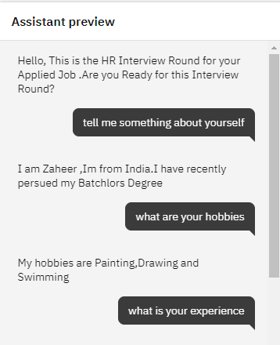

**RESULTS:**

Thus , AI based shortlister was built .